**1. Pwd**

* Pwd is used to print the current working directory.

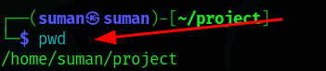

**2. cd**

* cd command is used to change the directory.

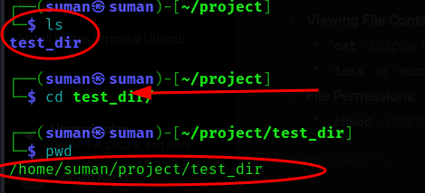

**3. ls**

* ls command is used to list the contents of a directory.

Eg:-

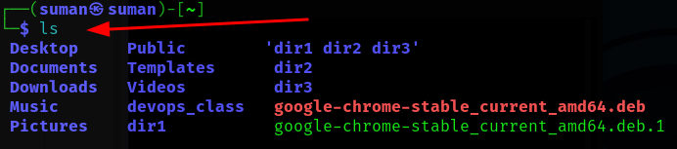

**4. Mkdir**

* mkdir is used to create directory in linux . It stand for Make Directory.

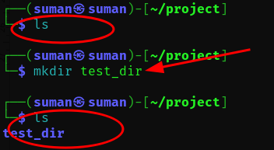

**5. rmdir**

* rmdir (remove directory) us used to remove empty directory

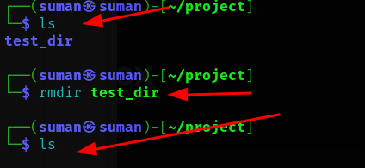

**6. Touch**

* Certainly! The touch command is used to create an empty file .

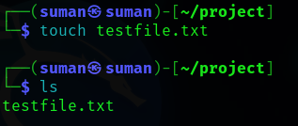

**7. rm**

* **a.** rm is used to remove file .

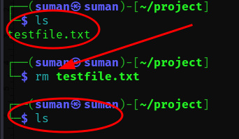

* **b.** rm or rm -rf is a powerful command in Linux . It used is to forcefully and recursively remove the directories and their contents without asking for confirmation.
* rm :- Remove command
* -r :- Recursively remove directories and their contents.
* -f :- Forcefully remove files without prompting for confirmation.

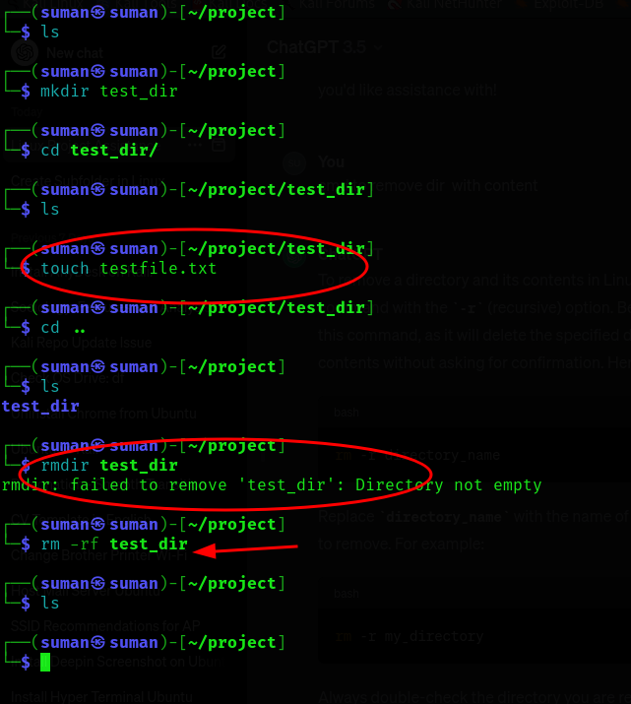

**8. Viewing File Content**

* **Cat**

cat stand for concatenate. It is the quick way to preview the contents of a text file without having to open the file.

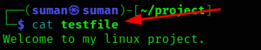

* **Less**
* **more**